# CS 255 Business Requirements Document Template

Complete this template by replacing the bracketed text with the relevant information.

This template lays out all the different sections that you need to complete for Project One. Each section has guiding questions to prompt your thinking. These questions are meant to guide your initial responses to each area. You are encouraged to go beyond these questions using what you have learned in your readings. You will need to continually reference the interview transcript as you work to make sure that you are addressing your client’s needs. There is no required length for the final document. Instead, the goal is to complete each section based on your client’s needs.

**Tip:** You should respond in a bulleted list for each section. This will make your thoughts easier to reference when you move into the design phase for Project Two. One starter bullet has been provided for you in each section, but you will need to add more.

## System Components and Design

### Purpose

*What is the purpose of this project? Who is the client and what do they want their system to be able to do?*

* The client is a company named DriverPass. Their goal is to improve DMV driver test pass rates. They need us to build their entire software infrastructure. The system will need to be accessible on and offline. The core of the system is web based and will have features such as a sign-up sheet for students, and a dashboard for current students.

### System Background

*What does DriverPass want the system to do? What is the problem they want to fix? What are the different components needed for this system?*

* The client needs to be able to access the information both on and offline. They also need a way for students to schedule different training events from one the offered packages through a user account. One part of the account is a dashboard where students and instructors can view things such as current test progress (a list of tests taken in relation to those needed to finish), an instructor comments section, as well as contact information.

### Objectives and Goals

*What should this system be able to do when it is completed? What measurable tasks need to be included in the system design to achieve this?*

* In addition to the things mentioned above, this system should be able to be easily changed should the owner need to edit packages or add or remove user privileges. This system ultimately should be able to cover all the needs laid out above. Each element above could be a measure of completeness.

## Requirements

### Nonfunctional Requirements

*In this section, you will detail the different nonfunctional requirements for the DriverPass system. You will need to think about the different things that the system needs to function properly.*

#### Performance Requirements

*What environments (web-based, application, etc.) does this system need to run in? How fast should the system run? How often should the system be updated?*

* This will need to be a web-based system that can be accessed offline.
* It will need to be available for access at all times via the internet.
* Anytime the company runs deals the online site will need to be updated.
* If updates come out for operating systems, search engines, or other supporting systems, this system will inevitably need an update.

#### Platform Constraints

*What platforms (Windows, Unix, etc.) should the system run on? Does the back end require any tools, such as a database, to support this application?*

* The system should run on all operating systems and should be versatile with its function on all search engines.
* Other than back end software everything should already be in place for the system to properly run. This is just an add-on to an existing system.

#### Accuracy and Precision

*How will you distinguish between different users?* *Is the input case-sensitive? When should the system inform the admin of a problem?*

* Each user has their own distinguishing characteristics given by a combination of their name and a number.
* Some inputs like passwords and usernames are case sensitive. Other inputs like a persons name are not case sensitive.
* Daily health checks should be automatically run on the system every morning and night.
* Malfunctions from the hardware or other issues of the system will need to be sent to an admin immediately.
* Bugs not caught should be recognized by users and sent to admins in the form of user complaints.

#### Adaptability

*Can you make changes to the user (add/remove/modify) without changing code? How will the system adapt to platform updates? What type of access does the IT admin need?*

* If an employee leaves or is employed, users will need to be easily added to the system for access.
* As people are employed or moved around the company, the access rights need to be dynamically updated.
* New customer accounts should be allowed to be dynamically added as well.
* IT personnel will have unique access to the entire system.
* User accounts will be the only thing IT personnel will not have direct access to.

#### Security

*What is required for the user to log in? How can you secure the connection or the data exchange between the client and the server? What should happen to the account if there is a “brute force” hacking attempt? What happens if the user forgets their password?*

* In order to login a user only needs a username and password.
* SSH is a very secure protocol that can be used to safely transfer data from user to server or vice versa.
* If an unauthorized user is in the system, it will be the job of the IT department to shut down the system, remove the user, restore lost data, and safely bring the system to it’s original open state.

### Functional Requirements

*Using the information from the scenario, think about the different functions the system needs to provide. Each of your bullets should start with “The system shall . . .” For example, one functional requirement might be, “The system shall validate user credentials when logging in.”*

* The system shall make changes to schedule based off of user input.
* The system shall conduct morning and nightly health checks
* The system shall create new objects for users added
* The system shall inform IT of issues needing resolution
* The system shall be open for access at all times (exceptions include hackers or necessary maintenance)

### User Interface

*What are the needs of the interface? Who are the different users for this interface? What will each user need to be able to do through the interface? How will the user interact with the interface (mobile, browser, etc.)?*

* An image of what is needed follows;

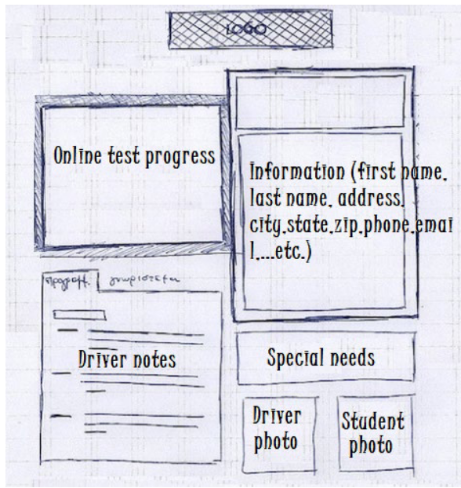

* The online test progress should show the tests the student took.
* It should show what’s in progress and the ones that the student completed. The test labels should include things like test name, time taken, score, and status. The status could be not taken, in progress, failed, or passed.
* Users of the UI will be faculty and students
* As stated above, interactions will occur via a search engine
* Faculty need to edit a table with notes from a given defined lesson
* Students only to have viewing rights to the above UI.
* Students need to be able to edit a student information page with things like their first and last name, address, and contact info.

### Assumptions

*What things were not specifically addressed in your design above? What assumptions are you making in your design about the users or the technology they have?*

* I am assuming that there are faculty who are competent in their field ready to make use of this new system.
* I assume that this company has the means to fund and support the growth of the system.
* If they do not currently have the support team necessary that they are in the process or have a plan to hire them

### Limitations

*Any system you build will naturally have limitations. What limitations do you see in your system design? What limitations do you have as far as resources, time, budget, or technology?*

* There is a direct correlation to the number of faculty to students that are able to be taught at one time.
* If there is no power available, the system does not operate.
* System growth would take another development team to construct.
* Without internet connection most users cannot access the site.

### Gantt Chart

*Please include a screenshot of the GANTT chart that you created with Lucidchart. Be sure to check that it meets the plan described by the characters in the interview.*

